+91-9849038304

We are one of the leading Manufacture, supplier and

exporter

of

a

wide

range

of

Medical

Equipment

and

Accessories, which is extremely durable and easy to

use.

In

addition

to

these,

we

are

also

engaged

in

providing Gas Monitoring Devices.

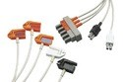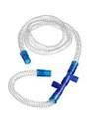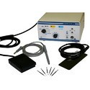

**Global Hi-Tech Solutions**

# P r o f i l e

Established in the year 1999, we, “Global Hi- Tech Solutions” are one of the reputed trader, supplier and exporter of a wide range of Medical Equipment and Accessories. Apart from these, we also offer a wide range of Gas Monitoring Devices. Our range of products is widely appreciated by clients in the market for durability and capability to deliver accurate results. These products are widely used in hospitals and laboratories. Our organization is an authorized distributor of Philips Electronics India Limited ( *Medical division*) and Micro Med Charts Mfg. Co. Pvt. Ltd. We also get our range customized from these companies as per client’s requirements. Our range of products is tested by our quality controllers before dispatching it at clients' end. Our huge distribution network is also sprawling across the Indian Subcontinent, which enables us to make the products available in the market at affordable prices. Our ethical business practices and client centric approach have enabled us to attain immense market appreciation. We have been progressing immensely under the able guidance of our mentor “Mr. Srinivasa Rao Bhadharla”. His vast industry experience and sharp business acumen are two of the inspirational factors that have helped us in gaining new heights in the market.

## MEDICAL CABLES

We are one of the leading **traders, suppliers** and **exporters** of a wide

range of **Medical Cables.**

P

r

o

d

u

c

t

s

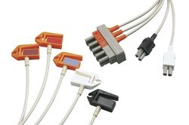

MIDA Cables and Leads

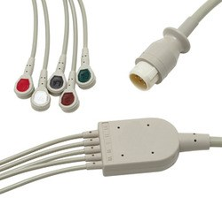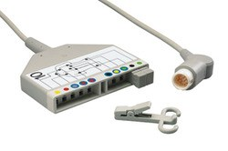

MIDA Cables and Leads

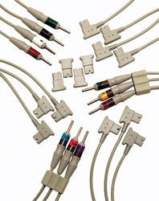

Cables and Leads Cables and Leads

**SPO2 SENSOR**

**Supplier**

&

**Manufacturer**

of

SpO2

Sensor

&

SPO2

Sensors

&

Accessories.

Our

product

range

also

comprises

of

Medical

Cables

and

Ventilator Accessories.

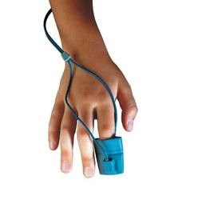

SpO2 Sensor

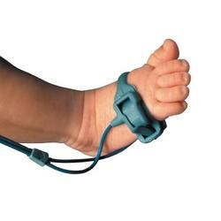

SpO2 Sensor

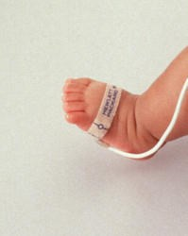

SpO2 Sensor

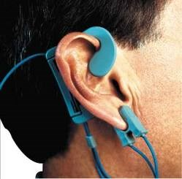

SpO2 Sensor

P

r

o

d

u

c

t

s

## MEDICAL PAPER

We are a leading Manufacturer & Exporter of Medical Paper such as ECG Medical Papers, ECG Medical Paper and Medical Papers from India.

P

r

o

d

u

c

t

s

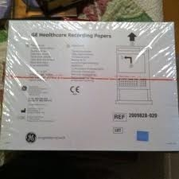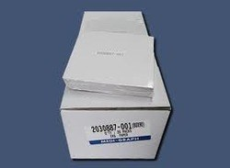

ECG Medical Papers ECG Medical Paper

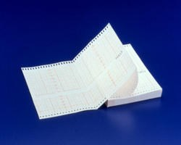

Medical Papers

## MEDICAL BATTERIES

We are a leading Manufacturer & Exporter of Medical Batteries such as AED Batteries and ABE Batteries from India.

P

r

o

d

u

c

t

s

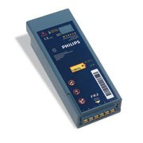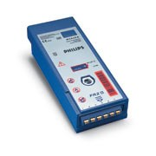

AED Batteries ABE Batteries

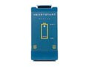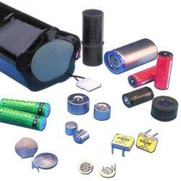

AED Batteries Medical Batteries

## TEMPERATURE PROBES

Leading Manufacturer and Exporter of Temperature Probes such as Temperature Probe and Disposable Temperature Probe from Hyderabad.

P

r

o

d

u

c

t

s

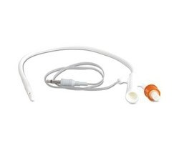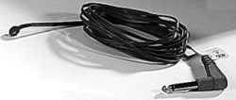

Temperature Probe Temperature Probes

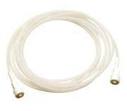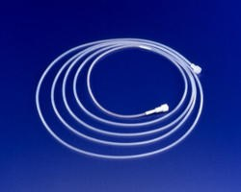

Temperature Probes Temperature Probe

**ECG PAPER**

Creating

a

niche

of

ECG

Paper

such

as

Fetal

Monitoring

Papers,

Fetal

Monitoring Recording Paper and ECG Paper Roll at its best, with utmost

quality.

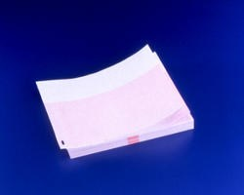

Fetal Monitoring Papers

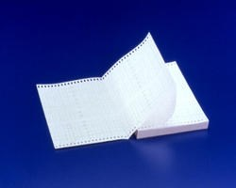

Fetal Monitoring

Recording Paper



ECG Paper

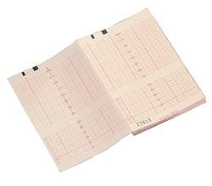

ECG Paper Roll

P

r

o

d

u

c

t

s

**DISPOSABLE ELECTRODES**

Creating

a

niche

of

Disposable

Electrodes

such

as

Medical

Electrodes,

Adult Monitoring and Stress Testing Electrodes for ECG and Disposable

Neonatal

and

Pediatric

Monitoring

Electrodes

at

its

best,

with

utmost

quality.

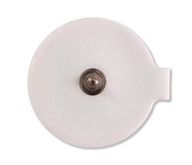

Medical Electrodes

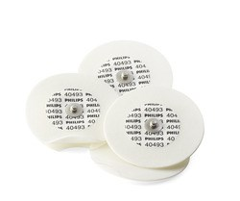

Disposable Electrodes

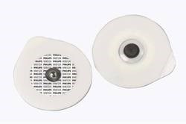

Adult Monitoring and

Stress Testing Electrodes

for ECG

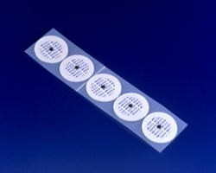

Adult Monitoring and

Stress Testing Electrodes

for ECG

P

r

o

d

u

c

t

s

**CARDIOGRAPHY ELECTRODES**

We

are

a

leading

Manufacturer

&

Exporter

of

Cardiography

Electrodes

such as Disposable Diagnostic Cardiograph Electrodes for Resting ECG,

Reusable Welsh-Bulb Electrodes- Chest Bulbs and Limb Plate Electrodes

from India.

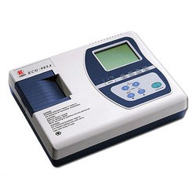

Cardiography Electrodes

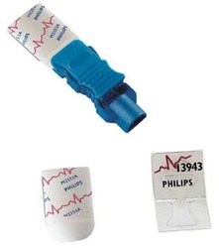

Disposable Diagnostic

Cardiograph Electrodes

for Resting ECG

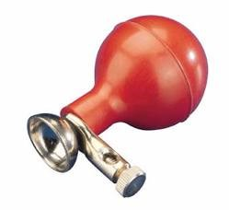

Reusable Welsh-Bulb

Electrodes- Chest Bulbs

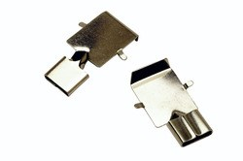

Limb Plate Electrodes

P

r

o

d

u

c

t

s

**ULTRASOUND GEL**

We

are

one

of

the

leading

traders,

suppliers

and

exporters

of

a

wide

range of Ultrasound Gel



Clinical Ultra Sound Jelleys



Laboratory Ultrasound

Jelly

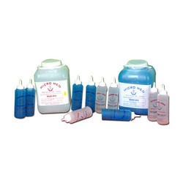

ECG Gel & EEG Pastes

P

r

o

d

u

c

t

s

**FETAL MONITORING SUPPLIES**

We are a leading Manufacturer & Exporter of Fetal Monitoring Supplies

such as Fetal Monitoring and Fetal Monitor Accessories from India.

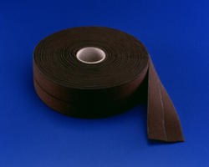

Fetal Monitoring

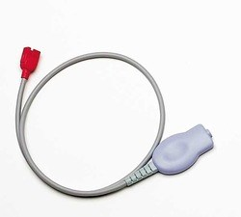

Fetal Monitoring Supplies



Fetal Monitoring Supplies

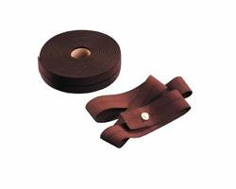

Fetal Monitoring Supplies

P

r

o

d

u

c

t

s

**NON INVASIVE BLOOD PRESSURE SUPPLIES**

Leading

Manufacturer

and

Exporter

of

Non

Invasive

Blood

Pressure

Supplies

such

as

Pressure

Cuff

Interconnect

Tubing,

NIBP

Supplies,

Pressure Cuff Interconnect Tubing for A1/A3 Monitors, Philips NIBP Cuff

and Philips Reusable and Disposable Cuff Models from Hyderabad.

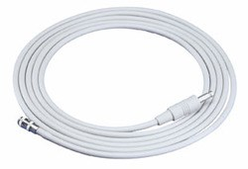

Pressure Cuff Interconnect

Tubing

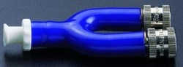

NIBP Supplies



NIBP Supplies

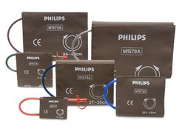

NIBP Supplies

P

r

o

d

u

c

t

s

**GAS MONITORING SUPPLIES**

Our product range includes a wide range of Gas Monitoring Supplies such

as

Tubing

Water-trap,

Calibration

Gas

Cylinder

and

Medical

Gas

Monitoring Supplies.

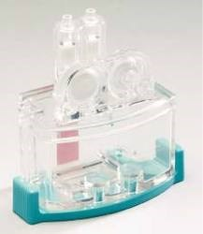

Tubing Water-trap



Calibration Gas Cylinder

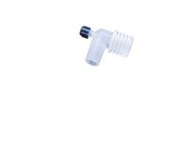

Medical Gas Monitoring

Supplies

P

r

o

d

u

c

t

s

**AED AND DEFIBRILLATORS SUPPLIES**

Manufacturer

&

Exporter

of

AED

and

Defibrillators

Supplies

&

Defibrillators.

Our

product

range

also

comprises

of

Medical

Cables,

Ventilator Accessories and Diathermy Accessories.

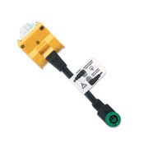

Defibrillators

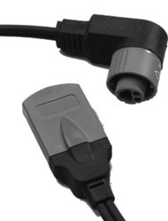

Defibrillators

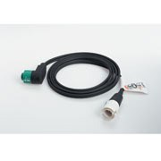

Defibrillators

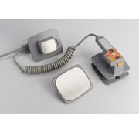

AED and Defibrillators

Supplies

P

r

o

d

u

c

t

s

F a c t s h e e t

Year of Establishment : 1999

Manufacturer, Exporter, Supplier, Distributor,

Nature of Business :

Trader

|  |  |
| --- | --- |
| Total Number of Employees : 11 to 25 People |  |
| Primary Competitive Advantage : Experienced R & D  Department | Large Product Line |
| Large Production  Capacity | Provide Customized  Solutions |
| Contract Manufacturing : Design Service Offered |  |